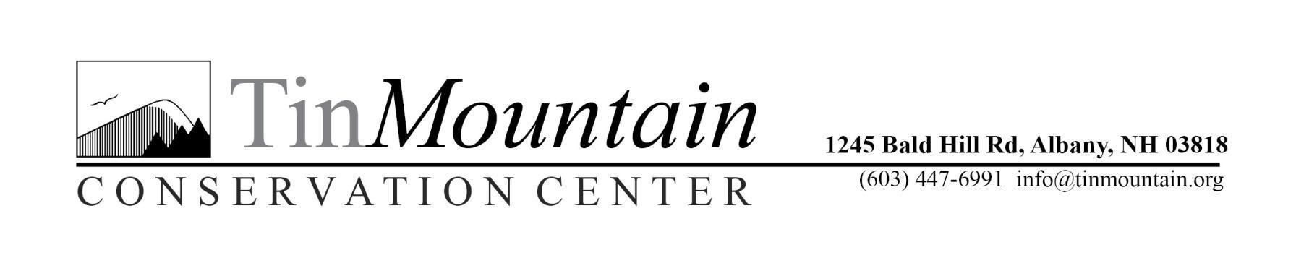
Summer Camp

Scholarship Application Form

Enrollment in Tin Mountain Camps and scholarships are on a first come, first served basis. Some camps fill very quickly; parents are encouraged to register for camp as soon as possible, and then send in their scholarship application.

Please complete the following information:

Camper’s Name ____________________________________________

Birth-date ________________ School _______________________ Grade ____

Parent/Guardian _________________________________________________________

Address ________________________________________________________________

Town ___________________________ State ____________ Zip _________________

Phone No. _______________________ Email ______________________________

Camp Session and Dates ___________________________________________________

Amount of Scholarship Requesting:
Please select the coverage that is best for your family. We encourage families to cover some cost, if financially possible, so that we may reach as many families with our scholarship funds.

❐ Full Scholarship (90% funds covered)
❐ Half Scholarship (50% of funds covered)
❐Quarter Scholarship (25% of funds covered)

Please describe briefly the reason(s) that you are requesting a camp scholarship:

